CHAPTER 05
SYSTEM DESIGN
5.1 Architectural Representation
The system architecture of the project "Detecting Criminal Activities from CCTV Using Object Detection and Machine Learning Algorithms" is structured into seven modular, interconnected layers designed for real-time video ingestion, deep learning computer vision inference, temporal threat validation, automated evidence generation, and role-governed human verification. Figure 5.1.1 illustrates the architectural representation and data flow among all system components.
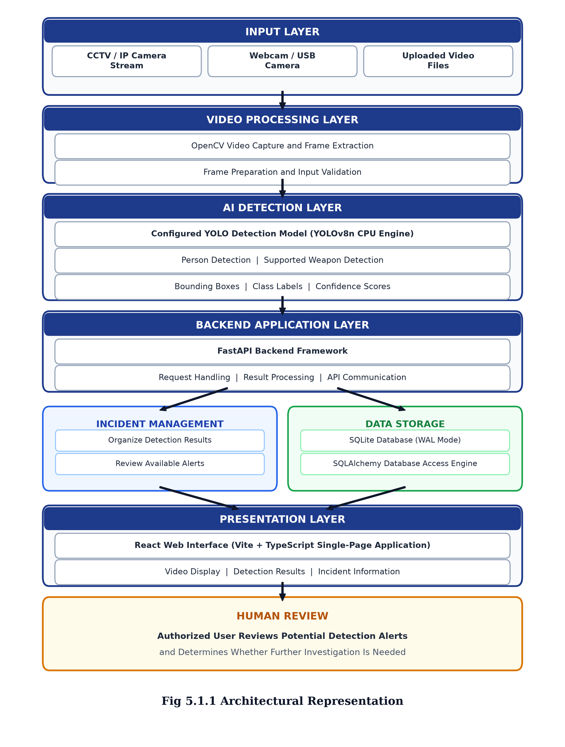
Fig 5.1.1 Architectural Representation

5.2 Architectural Description
General Architectural Overview
The architecture of the "Detecting Criminal Activities from CCTV" project consists of several connected components that work together seamlessly to capture, process, and analyze video footage in real-time. The core philosophy of this architecture is to decouple high-frequency frame ingestion from neural network inference, allowing smooth 25–30 FPS live surveillance monitoring while executing deep convolutional neural network inferences at an adaptive, resource-efficient rate on standard multi-core CPU hardware without requiring dedicated enterprise GPU clusters.
1. Input Layer
The Input Layer serves as the entry gateway for all live and recorded visual data. It abstracts disparate video sources, including commercial CCTV IP cameras streaming over network protocols (RTSP/HTTP), local integrated webcams, external USB video capture cards, and pre-recorded surveillance video files (MP4, AVI, MKV) uploaded for forensic batch investigation. The ingestion layer employs standardized communication protocols, enforcing TCP packet transport for network streams to eliminate UDP packet fragmentation and visual frame tearing.
2. Video Processing Layer
The Video Processing Layer operates as a multi-threaded frame acquisition and normalization engine powered by OpenCV (cv2.VideoCapture). Dedicated background daemon worker threads interface directly with each video stream, continually extracting raw video frames at native clock frequencies. This layer implements input validation, frame resizing to a standard 640x480 resolution, and color-space conversion from OpenCV BGR to RGB format. Concurrently, an in-memory circular double-ended buffer (collections.deque) maintains a rolling 3.0-second cache of historical frames, ensuring zero-loss pre-incident video evidence preservation.
3. AI Detection Layer
The AI Detection Layer houses the core machine learning inference engine utilizing the state-of-the-art Ultralytics YOLOv8n (You Only Look Once version 8 nano) deep learning network. Optimized specifically for multi-core CPU inference via vectorized SIMD and AVX instruction sets, this layer performs real-time feature extraction using Cross-Stage Partial (C2f) modules and Spatial Pyramid Pooling Fast (SPPF). The layer operates specialized models: a general detection model for person and crowd spatial tracking, and a custom-trained weapon detection model targeting handguns, rifles, and bladed weapons. Output detections include bounding box spatial coordinates, class identity labels, and softmax confidence scores. Non-Maximum Suppression (NMS) with an IoU threshold of 0.45 filters redundant candidate boxes.
4. Backend Application Layer
The Backend Application Layer is constructed upon the asynchronous FastAPI Python framework running on an ASGI Uvicorn server. It orchestrates system services, request routing, background task workers, and client communications. This layer dispatches video frames from the stream manager to the AI detection engine, manages multi-part live MJPEG video broadcast streams directly to web clients, and coordinates the temporal multi-frame confirmation gate that validates candidate threats across consecutive video frames to prevent false alarms caused by fleeting shadows or handheld items.
5. Incident Management Subsystem
The Incident Management Subsystem automatically triggers upon confirmation of a criminal anomaly. Once a threat candidate exceeds the validation threshold across consecutive frames (K >= 2), this subsystem captures the incident metadata, extracts the 3.0-second pre-event footage from the RAM circular buffer, appends 3.0 seconds of post-event footage, and encodes a complete 6.0-second MP4 evidence video. Additionally, it isolates the exact keyframe displaying peak detection confidence, overlays localized bounding boxes, and generates a high-definition JPEG thumbnail for rapid triage.
6. Data Storage Subsystem
The Data Storage Subsystem guarantees ACID-compliant persistence and high-concurrency access via SQLite 3 operating in asynchronous Write-Ahead Logging (WAL) mode. Managed through SQLAlchemy 2.0 object-relational mapping, WAL mode decouples database readers from writers, ensuring that multiple dashboard operators can simultaneously query incident logs, camera status records, and audit ledgers while video processing threads write new incident entries with sub-millisecond latency. Physical media files are organized into structured directories for evidence clips (/storage/incidents/) and model weights.
7. Presentation Layer
The Presentation Layer provides a modern, responsive Single-Page Application (SPA) developed with React 18, TypeScript, Tailwind CSS, and Vite. It furnishes security personnel with an integrated command dashboard featuring a live multi-camera CCTV monitoring grid, a forensic video batch analysis queue, an incident review and triage center, a weapon detection validation suite, and an evidence video playback library. The presentation layer connects to the backend through asynchronous REST APIs and high-efficiency MJPEG stream endpoints.
8. Human Review & Role-Based Access Control (RBAC)
The Human Review component represents the final supervisory governance tier, ensuring that AI-detected anomalies are reviewed by qualified personnel before law enforcement escalation. The system enforces strict Role-Based Access Control (RBAC): Field Operators possess read-only clearance to monitor live feeds; Threat Analysts possess forensic clearance to acknowledge, review, and dismiss incident alerts and export certified reports; while System Administrators retain full authority to configure camera endpoints, tune AI confidence thresholds, and manage operator clearances.
Table 5.1 System Architecture Component and Technology Summary
Architecture Layer | Core Technology | Functional Role
Input Layer | RTSP, TCP, Webcams, MP4 Files | Captures raw video feeds from multiple camera endpoints at 25-30 FPS.
Video Processing Layer | OpenCV (cv2.VideoCapture) | Decouples frame capture from AI, resizes to 640x480, buffers 3s in RAM.
AI Detection Layer | YOLOv8n, PyTorch CPU Engine | Executes real-time object detection for persons, weapons, and anomaly bounding boxes.
Backend Layer | FastAPI, Uvicorn ASGI Server | Manages asynchronous REST APIs, route handling, and multipart MJPEG stream broadcast.
Incident Management | Temporal Multi-Frame Gate | Confirms threats over consecutive frames, packages 6s MP4 clips and JPEG thumbnails.
Data Storage | SQLite 3 (WAL Mode), SQLAlchemy | Maintains relational schema for cameras, incidents, and audit logs with non-blocking reads.
Presentation Layer | React 18, TypeScript, Tailwind | Renders responsive operator command console, multi-view feeds, and triage center.
Human Review / RBAC | Clearance Governance Engine | Provides 3-tier access control (Admin, Analyst, Operator) for verified human oversight.

